# Department of Computing

# database systems

# Course Instructor: Dr. shams qazi

# Lab 04: Introduction to SQL

## **CS220: DB Systems**

## **Name : Mahum Samar**

## **CMS ID : 290647**

## **Class: BSCS 9B**

1. Retrieve first and last name of actors who played in AFRICAN EGG.

SELECT first_name, last_name FROM sakila.actor, sakila.film_actor, sakila.film

WHERE film.film_id = film_actor.film_id

AND film_actor.actor_id = actor.actor_id

AND film.title = "AFRICAN EGG";

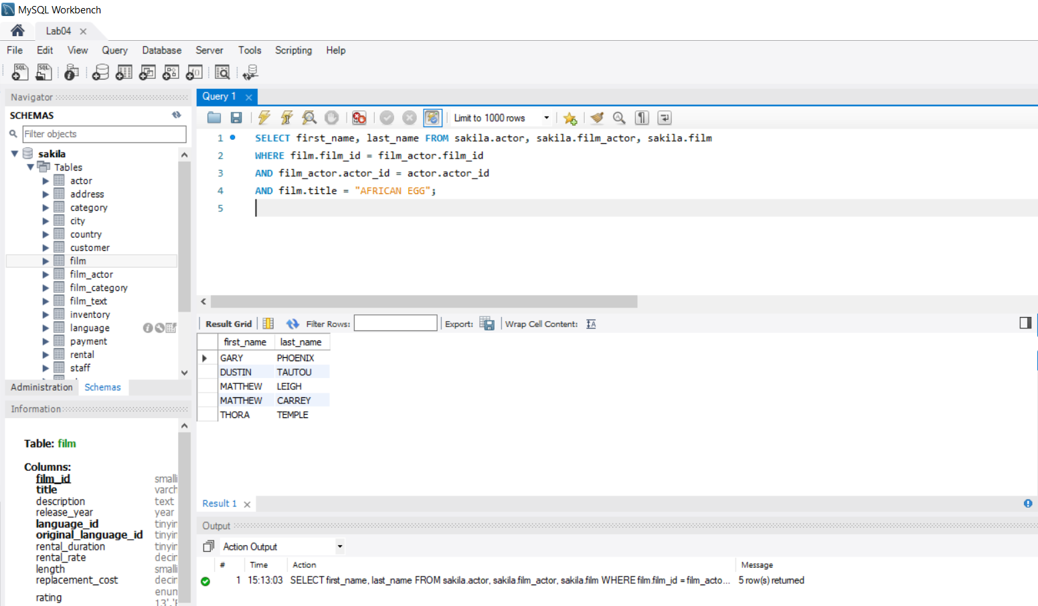

1. Retrieve actor id and their names with their addresses.

In the actor table there is no such attribute which can be linked with address table.

So, I have used the customer table instead.

SELECT customer_id, first_name, last_name, address, district,

city, country

FROM sakila.customer, sakila.address, sakila.city, sakila.country

WHERE customer.address_id = address.address_id

AND address.city_id = city.city_id

AND city.country_id = country.country_id;

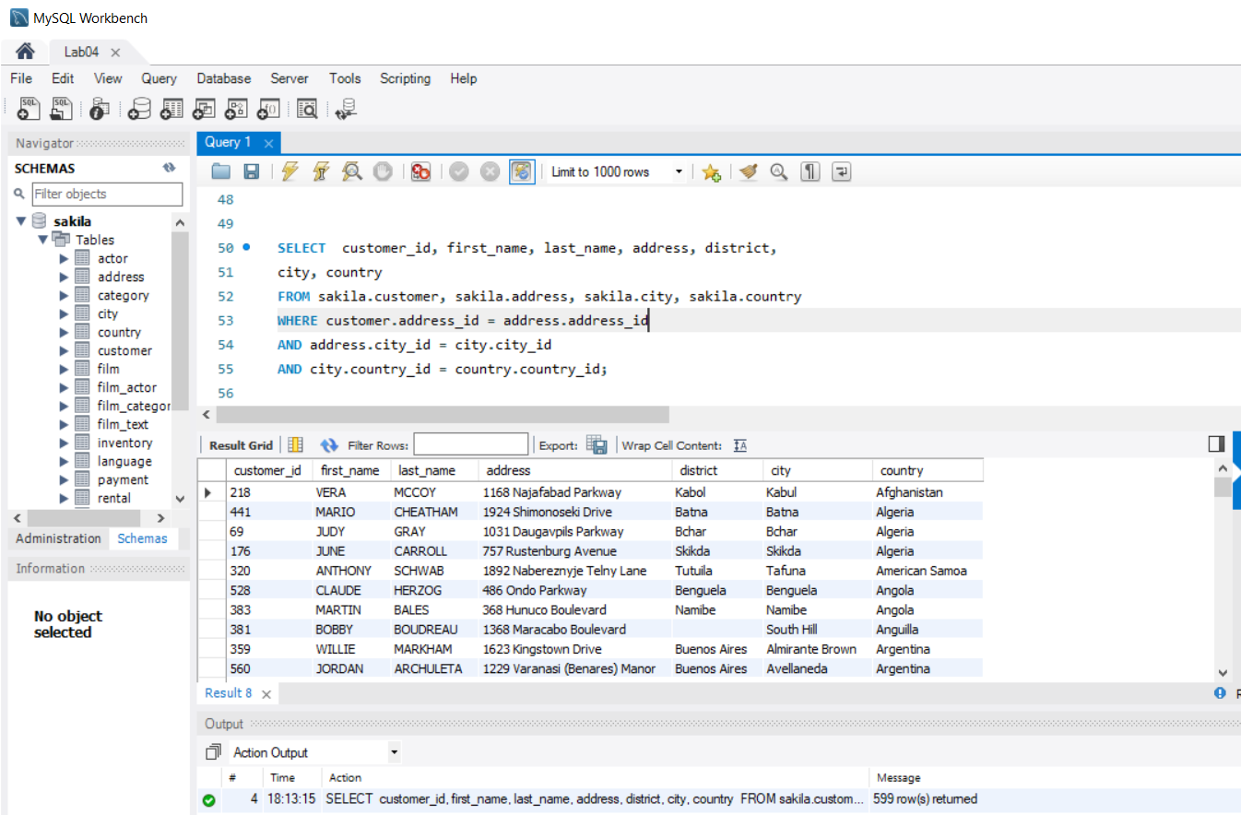

1. Retrieve names of movies starting with A.

SELECT title FROM sakila.film

WHERE film.title LIKE 'A%';

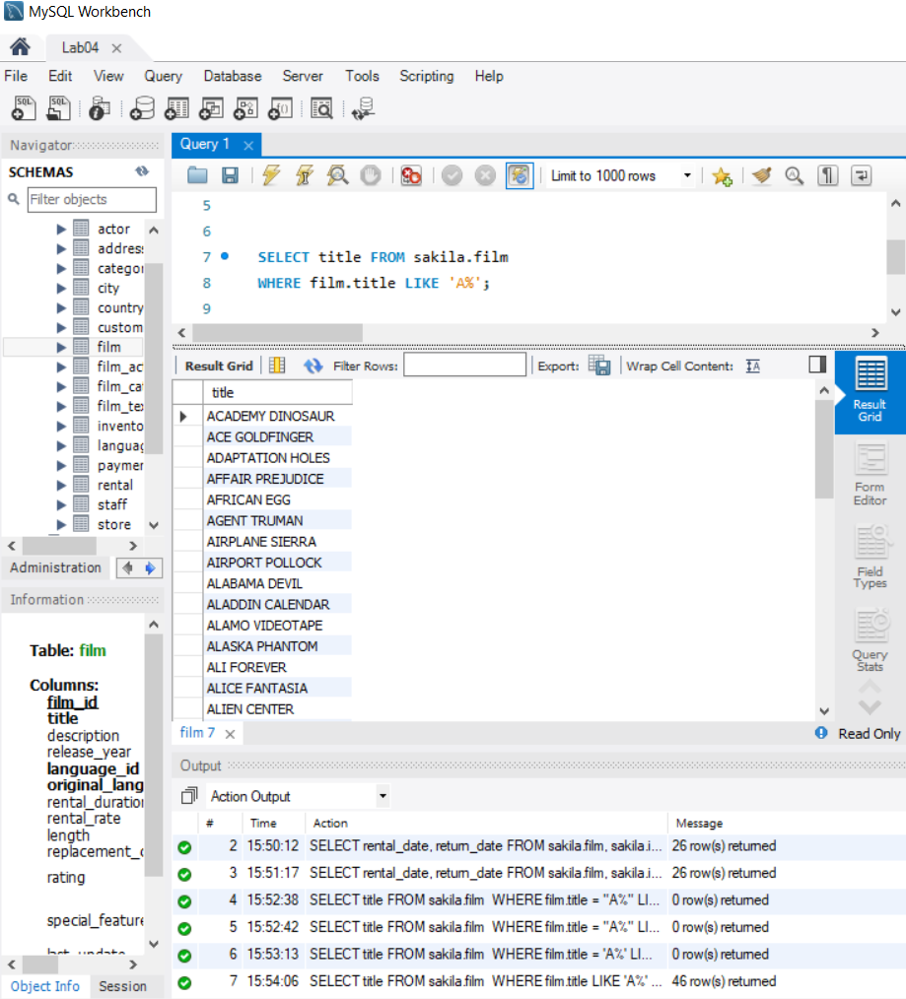

1. Retrieve data of all actors whose names are not starting with Z.

SELECT * FROM sakila.actor

WHERE actor.first_name NOT LIKE 'Z%';

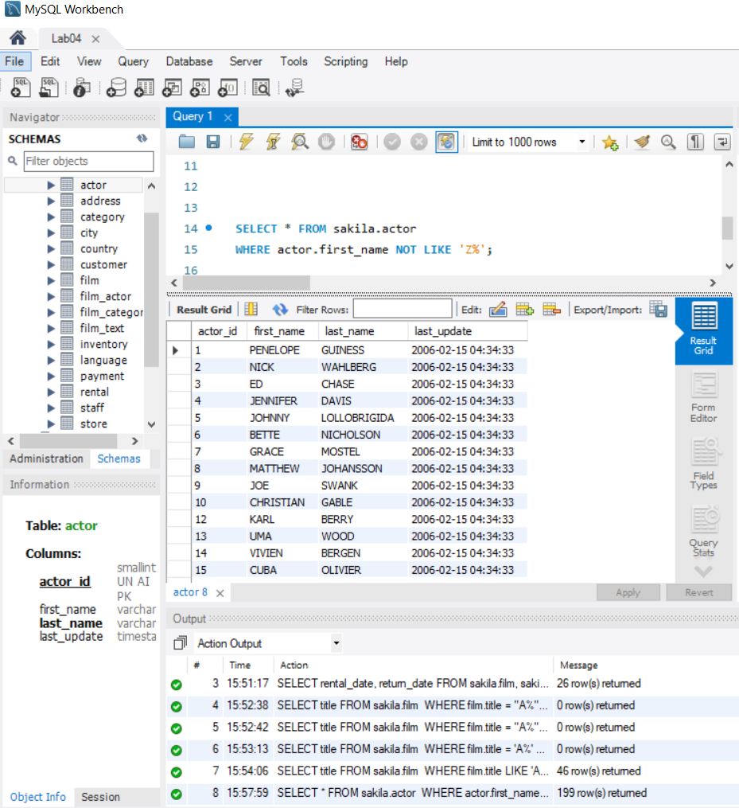

1. Retrieve rental and return date for the movie ALASKA PHANTOM.

SELECT rental_date, return_date FROM sakila.film,sakila.inventory,

sakila.rental

WHERE film.title = "ALASKA PHANTOM"

AND film.film_id = inventory.film_id

AND inventory.inventory_id = rental.inventory_id;

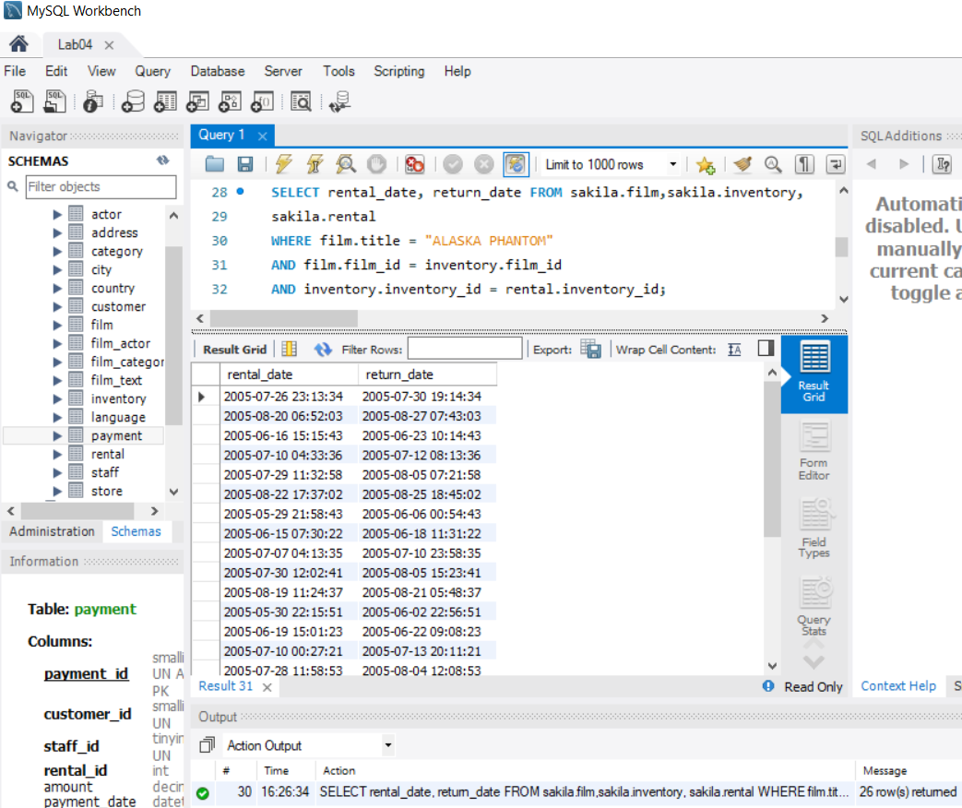

1. Find and display the Income (payments) generated during August 2005. Sort them in the descending order.

SELECT amount, payment_date FROM sakila.payment

WHERE payment_date BETWEEN '2005-08-01' AND '2005-08-31'

ORDER BY payment.amount DESC;

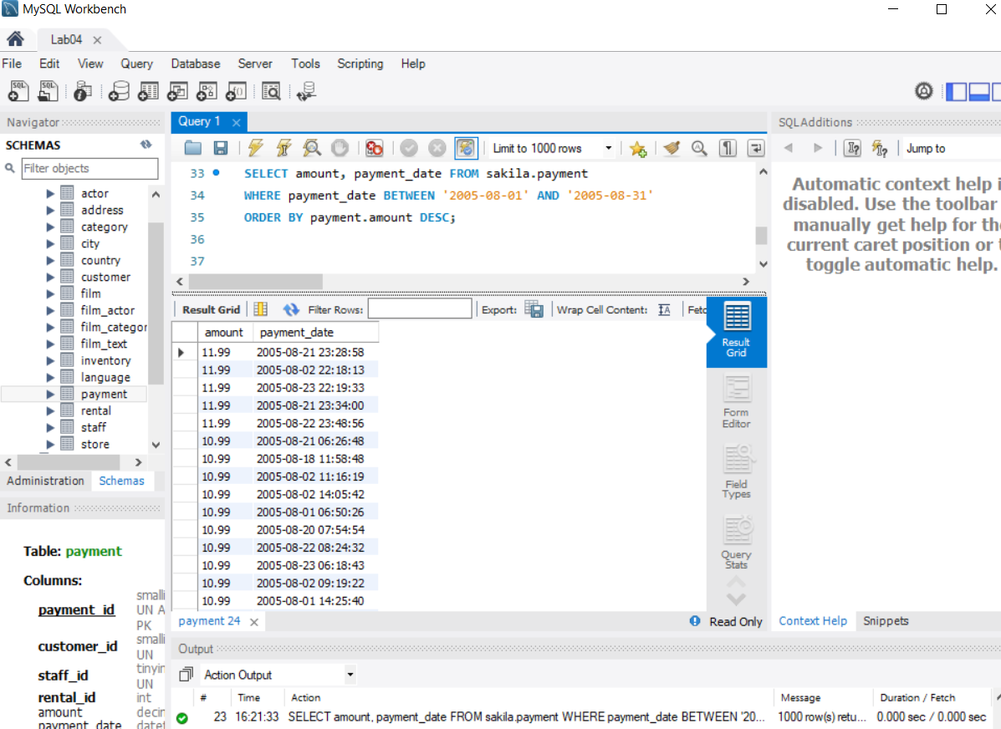

1. Find and display the Email addresses of customers who haven’t paid even a single penny yet.

SELECT email FROM sakila.customer, sakila.payment

WHERE payment.amount = 0

AND customer.customer_id = payment.customer_id;

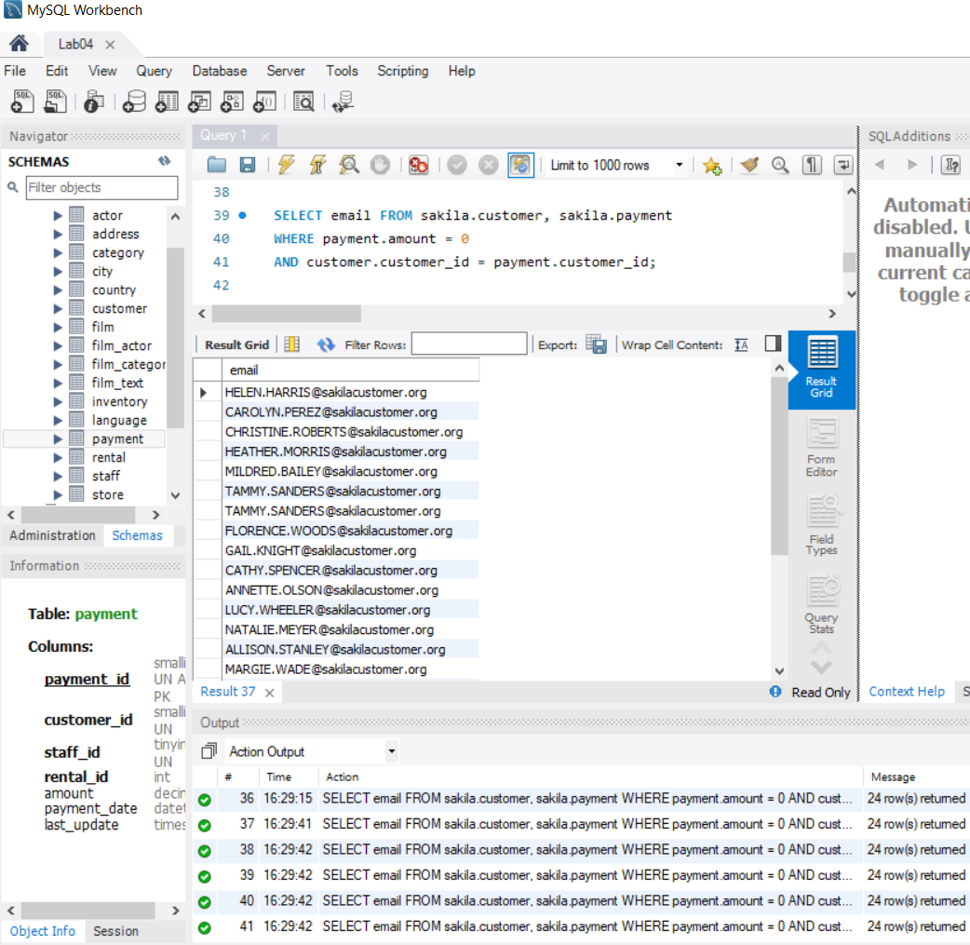

1. Extract information of actors whose names ends with character ‘T’

SELECT * FROM sakila.actor

WHERE actor.last_name LIKE '%T';

